Additional file 1

Evolutionary engineering improved D-glucose/xylose co-fermentation of Yarrowia lipolytica

Linlin Zhou¹, Zhiqiang Wen^{1*}, Zedi Wang¹, Yuwei Zhang¹, Rodrigo Ledesma-Amaro², Mingjie Jin^{1*}
¹ School of Environmental and Biological Engineering, Nanjing University of Science & Technology, Nanjing, 210094, China
² Department of Bioengineering, Imperial College London, London SW7 2AZ, UK

*Corresponding authors: Mingjie Jin, E-mail: jinmingjie@njust.edu.cn (ORCID: 0000-0002-9493-305X); Zhiqiang Wen, E-mail: zqwen@njust.edu.cn (ORCID: 0000-0001-8083-7588)

Author Contributions
Linlin Zhou, Zhiqiang Wen, Zedi Wang, and Yuwei Zhang performed the experiments, and analyzed the data; Zhiqiang Wen and Mingjie Jin coordinated and supervised this study; Linlin Zhou, Zhiqiang Wen, Mingjie Jin and Rodrigo Ledesma-Amaro drafted and revised the manuscript.

Additional Table S1 qRT-PCR primers used in this study.
Primer name | Sequence (5’-3’) | Description
YALI0_E23287g- rt-F | catgaccattcctgccctgctcttc | Forward real-time PCR primer for gene YALI0_E23287g
YALI0_E23287g- rt-R | cttgaaggcggtaggcac | Revise real-time PCR primer for gene YALI0_E23287g
YALI0_E20427g- rt-F | acgcccaggctaacttgc | Forward real-time PCR primer for gene YALI0_E20427g
YALI0_E20427g- rt-R | tgggaccaatgacaacagac | Revise real-time PCR primer for gene YALI0_E20427g
YALI0_D18876g- rt-F | ctaatgaagataggcaagga | Forward real-time PCR primer for gene YALI0_D18876g
YALI0_D18876g-rt-R | agagtagaccgtcacagca | Revise real-time PCR primer for gene YALI0_D18876g
YALI0_D01111g- rt-F | cgaggctgctggtgtctt | Forward real-time PCR primer for gene YALI0_D01111g
YALI0_D01111g -rt-R | cgagttggtggcgttcat | Revise real-time PCR primer for gene YALI0_D01111g
YALI0_C04730g- rt-F | caccatccaaggcacagc | Forward real-time PCR primer for gene YALI0_C04730g
YALI0_C04730g -rt-R | acagggaaccgccagtca | Revise real-time PCR primer for gene YALI0_C04730g
YALI0_D00363g - rt-F | gcttccgttgtctgtgct | Forward real-time PCR primer for gene YALI0_D00363g
YALI0_D00363g -rt-R | gggagtgccttggagtta | Revise real-time PCR primer for gene YALI0_D00363g
YALI0_B00396g- rt-F | tttacccgacgctccatt | Forward real-time PCR primer for gene YALI0_B00396g
YALI0_B00396g-rt-R | caccacgcccaggctatt | Revise real-time PCR primer for gene YALI0_B00396g
YALI0_E20207g- rt-F | gcagccaactacatttcca | Forward real-time PCR primer for gene YALI0_E20207g
YALI0_E20207g -rt-R | gacaagtctcgcagaatcagt | Revise real-time PCR primer for gene YALI0_E20207g

Additional Table S2 Ten most upregulated genes in yl-XYL*04*10 compared to yl-XYL+ in YPD₃₀ X₃₀ medium.
Gene id | Fold Change | KOG/Description
YALI0_A21439g | 14.1 | -
YALI0_B16214g | 12.3 | KOG1250-Threonine/serine dehydratases[E]
YALI0_D19140g | 9.2 | KOG1261-Malate synthase[C]
YALI0_F25289g | 6.3 | KOG0101-Molecular chaperones HSP70/HSC70, HSP70 superfamily[O]
YALI0_C23452g | 6.0 | -
YALI0_D08184g | 5.6 | KOG0101-Molecular chaperones HSP70/HSC70, HSP70 superfamily[O]
YALI0_A09856g | 5.6 | KOG2040-Glycine dehydrogenase (decarboxylating)[E]
YALI0_F01254g | 4.6 | KOG1286-Amino acid transporters[E]
YALI0_F27577g | 4.2 | -
YALI0_C19844g | 3.8 | -

Additional Table S3 Ten most downregulated genes in yl-XYL+*04*10 compared to yl-XYL+ in YPD₃₀ medium.
Gene id | Fold Change | KOG/Description
YALI0_E07051g | 0.32 | KOG0257-Kynurenine aminotransferase, glutamine transaminase K[E]
YALI0_F07975g | 0.33 | KOG3945-Uncharacterized conserved protein[S]
YALI0_D21890g | 0.33 | KOG4342-Alpha-mannosidase[G]
YALI0_D01111g | 0.37 | KOG0254-Predicted transporter (major facilitator superfamily)[R]
YALI0_C21516g | 0.40 | -
YALI0_D20262g | 0.41 | KOG2329-Alkaline ceramidase[I]
YALI0_D09801g | 0.43 | KOG3098-Uncharacterized conserved protein[S]
YALI0_E24211g | 0.46 | -
YALI0_C07678g | 0.47 | KOG1286-Amino acid transporters[E]
YALI0_A10362g | 0.48 | KOG3729-Mitochondrial glycerol-3-phosphate acyltransferase GPAT[I]

Additional Table S4 DNA sequence mutation in yl-XYL+*04*10 compared to yl-XYL+
Position | Sequence change | Gene | Protein change | Definition
2232906 | G→A | YALI0_C15741g | W15 Stop Codon(tGg→tAg)
2740391 | A→C | YALI0_E23287g,SNR17 | N373T(aAc→aCc) | KOG0254-Predicted transporter (major facilitator superfamily)[R]
1144230 | A→T | YALI0_C08393g | E645V(gAg→gTg) | KOG3770-Acid sphingomyelinase and PHM5 phosphate metabolism protein[I]
1394137 | T→C | YALI0_E11407g,SNR17 | V683A(gTc→gCc) | KOG1399-Flavin-containing monooxygenase[Q]
1394158 | G→A | YALI0_E11407g,SNR17 | S690N(aGt→aAt) | KOG1399-Flavin-containing monooxygenase[Q]
1159994 | A→T | YALI0_C08473g | E1243V(gAg→gTg) | -
1159995 | G→T | YALI0_C08473g | E1243V(gaG→gaT) | -
1159996 | A→C | YALI0_C08473g | T1244P(Act→Cct) | -
853301 | T→G | YALI0_A08624g,RPR1 | H62Q(caT→caG) | -
962917 | C→A | YALI0_A09614g,RPR1 | R135H(cGc→cAc) | -
1842321 | G→C | YALI0_E15488g,SNR17 | G270A(gGa→gCa) | KOG1369-Hexokinase[G]
815104 | T→C | YALI0_E07139g,SNR17 | S468P(Tcc→Ccc) | KOG1992-Nuclear export receptor CSE1→CAS (importin beta superfamily)[YU]
2241808 | A→C | YALI0_C15785g | N19H(Aat→Cat) | -

Additional Figure S1. Fermentation phenotype test of randomly selected colonies derived from their parental strains. (A) stage 1; (B) stage 2; (C) stage 3; (D) stage 4. At the end of each evolution stage, the culture populations from the last batch were harvested spread on solidified medium. Then 10 colonies were randomly picked to cultivate in liquid YNBdG_{x}G₂X₁₀ medium for 24 h to compare with each other. For stage I, yl-XYL+*01*3 exhibited best. Thus, it was selected and used for subsequent evolution. yl-XYL+*02*9, yl-XYL+*03*5 and yl-XYL+*04*10 are obtained in the same way.
.
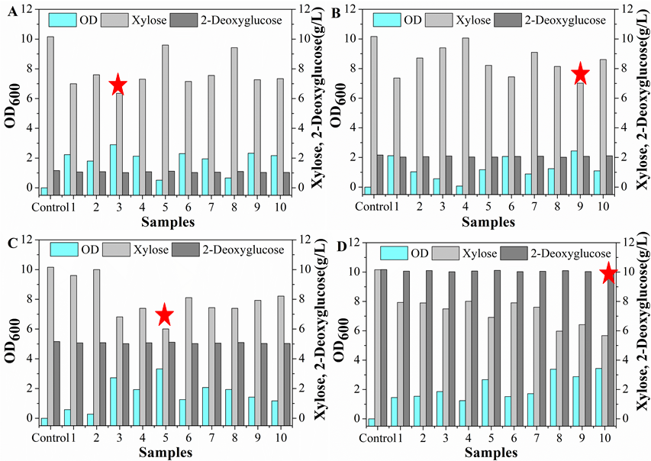

Additional Figure S2. Growth and morphology of parent and evolved strains. (A), growth phenotype of parent strain yl-XYL+ and 4 mutants selected from 4 evolution stages (yl-XYL+*01*3, yl-XYL+*02*9, yl-XYL+*03*5 and yl-XYL+*04*10) on YNBdG₁X₁₀ solid medium; (B), morphology of parent and evolved strain in optical microscope with 1000-fold enlarge.
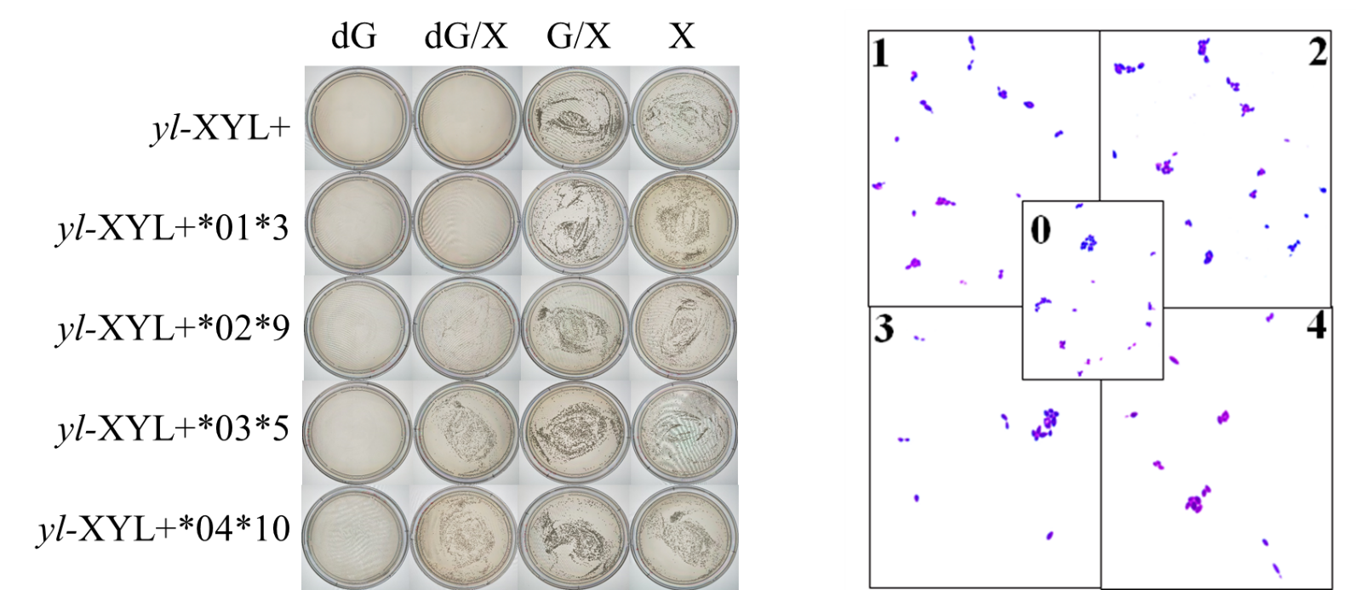
B
A

Additional Figure S3. Fermentation phenotype test of original and evolved strains in arabinose medium. (A), All strains cannot grow with arabinose as sole carbon source; (B), Fermentation phenotype in YNBD₁₅A₁₅ medium at 24 h; (C), Fermentation phenotype in YNBD₁₅A₁₅ medium at 48 h.
A
B
C
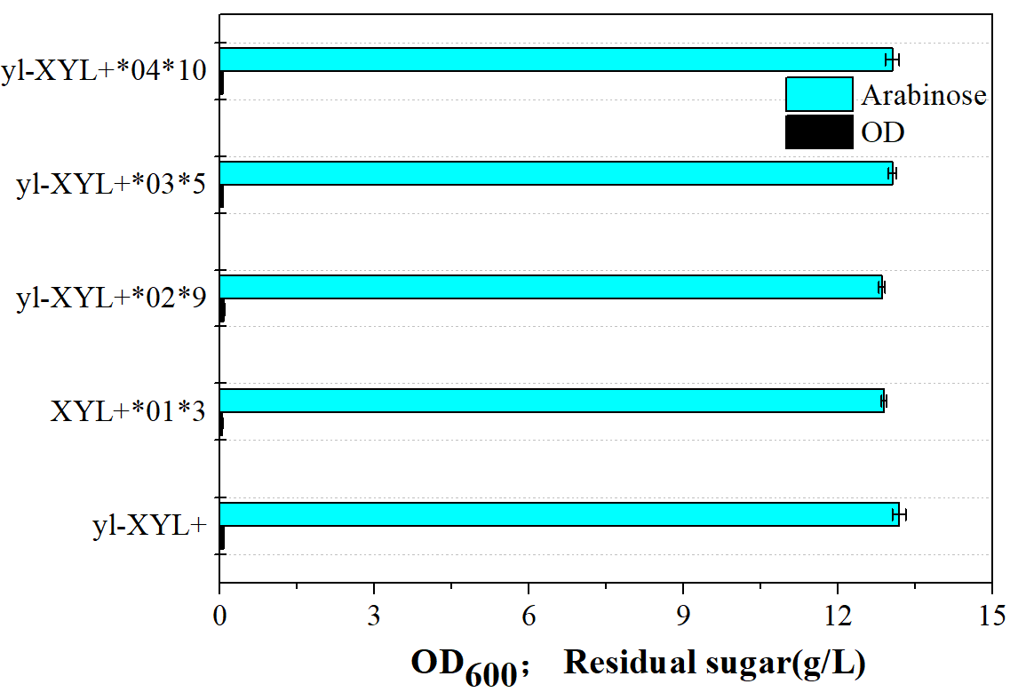
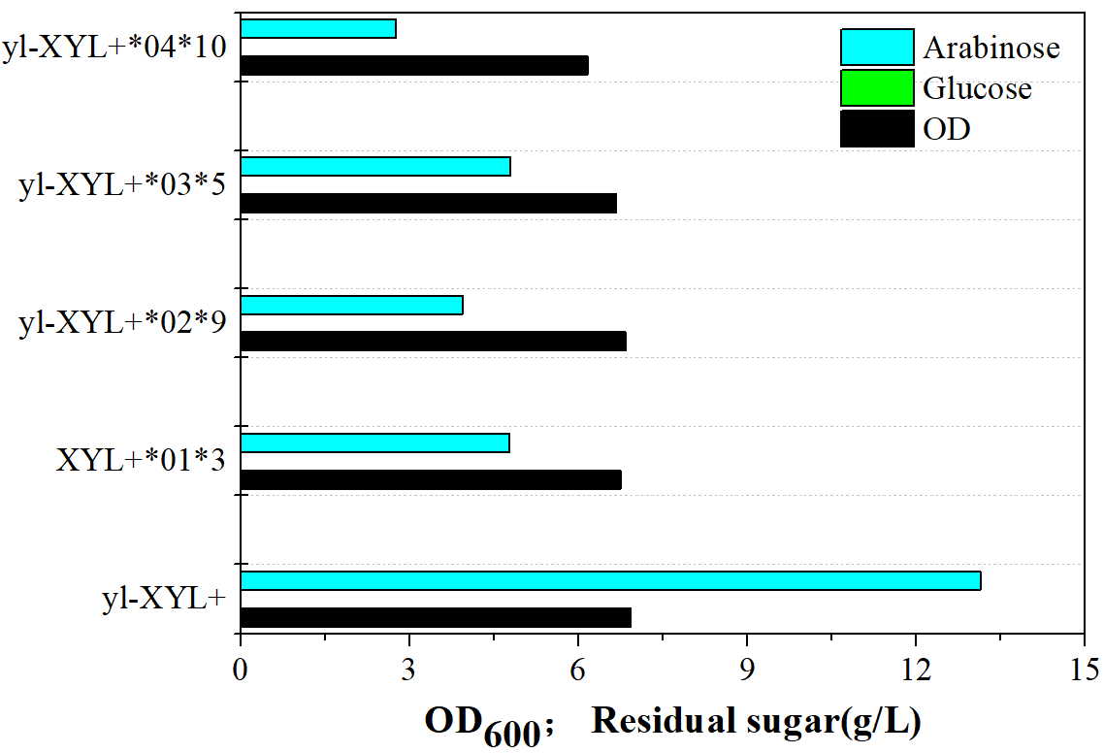
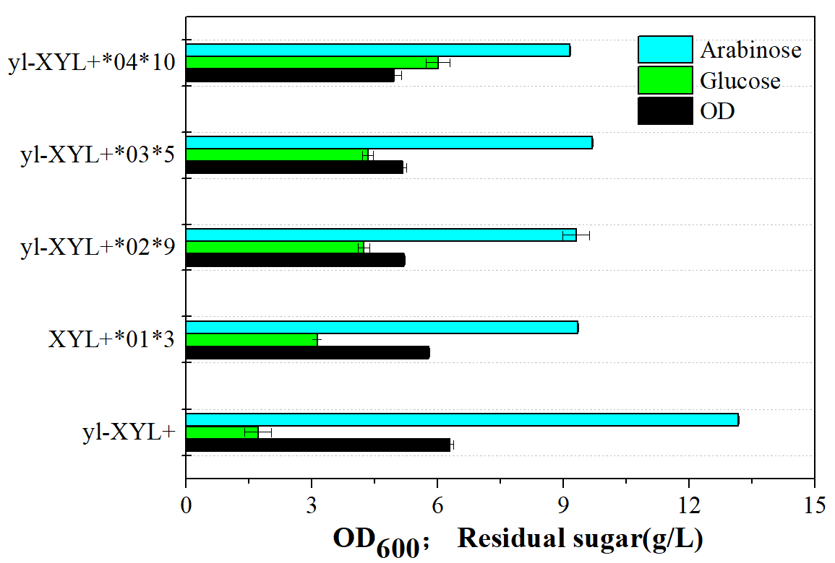

Additional Figure S4. PCR amplification and DNA sequencing confirmed point mutation in YALI0_E23287g (A) and YALI0_E15488g (B).
